
2026 LECTURE PROGRAM

Monday 16 March
Susan Kay-Williams presents
Imperial Purple to Marie Antoinette’s Fleas

Monday 25 May
Zara Fleming presents
Journey Across the Himalayas

Monday 20 July
Charlie Hall presents
Peggy Guggenheim: A Life of Collecting

Monday 24 August
Tessa Boase presents
London’s Lost Department Stores

Monday 21 September
Mariska Beekenkamp-Wladimiroff presents
Mondrian’s Evolution into Abstraction

Monday 26 October
Graham Jones presents
The Art of State Ceremonial Music

Lectures commence at 10:30 am
and are usually of an hour’s duration
Refreshments served from 9:45am
Visitors welcome $30 at the door

CONNECT ENRICH INSPIRE
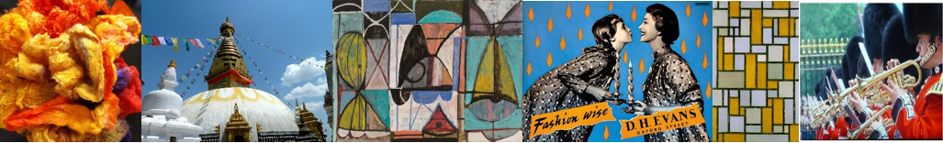


ARTSNATIONAL Fleurieu
Membership Form 2026

For more information: www.adfasfleurieu.com.au
Email: artsnationalfleurieu@gmail.com

Preferred First Name for Membership Badge:

……………………………………………………………..
Surname:

……………………………………………………………..
Postal Address:

……………………………………………………………..

……………………………………………………………..

……………………………………………………………..
Telephone:

……………………………………………………………..
Email:

……………………………………………………………..

Members’ contact details may be used for the purposes of
registration and communication.

Members rejoining 2026: $160
New members add joining fee of $10: $170

Direct Deposit — Please quote your full name
Account name: ADFAS Fleurieu
(AUSTRALIAN DECORATIVE & FINE ARTS SOCIETY FLEURIEU)
BSB: 085 938 Account No: 741 618 633

Email form to artsnationalfleurieu@gmail.com or
Mail to PO Box 602, Victor Harbor SA 5211
ADFAS Fleurieu Inc. ABN 87 123 387 585

VENUE FOR LECTURES:
Gospel Centre
2 George Main Road, Victor Harbor 5211

